TO : EVAWD OFFICERS AND GENERAL MANAGERS

FROM : CYRIL LUIS L ARRADAZA

SUBJECT : 2nd EVAWD MEETING

DATE : AUGUST 22, 2014

X ==============================================/

Please be informed that we are calling special meeting on August 22, 2014, 9:00 A.M at Ocho Grill, Tacloban City, on matters pertaining to general interest and concern of EVAWD members.

Registration fee is EIGHT HUNDRED (P800.00) PESOS per participant to defray the expenses for food, venue and other miscellaneous expenses during the meeting. For further details and confirmation of attendance, you may contact Ms. Elsie C. Almario or Ms. Garnet P. Lim at Telephone Nos. (053) 563-8359; 335-4156; 563-9478.

Thank you for your continued support to our association.

Thank you.

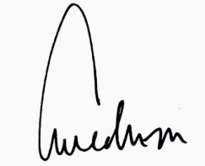

CYRIL LUIS L. ARRADAZA

